Homework 9

|  |  |
| --- | --- |
| **Meta information** | |
| Name | Savan Kiran |
| Program | Masters in Computer Science |
| Questions skipped | N/A |
| Questions substituted | N/A |
| Extra credit questions | N/A |

# PART A

1. We first use the **vl_sift** matlab interface to find all the keypoints in both the low-resolution frame image and the high-resolution slide image. We use the grayscale pgm format images for keypoint detection and plot them on the color variants of the corresponding images. We find the best slide keypoint for every frame keypoint using the nearest neighbor computed from the Euclidean distance of the 128-element feature vector. Since the keypoint matches are large, we visualize a subset of them by choosing every 5th pair.

The yellow lines in Figure 1, 2 & 3 indicate the keypoints. The keypoint is placed at a certain x & y position with length showing the scale and angle showing the orientation of the keypoint vector.

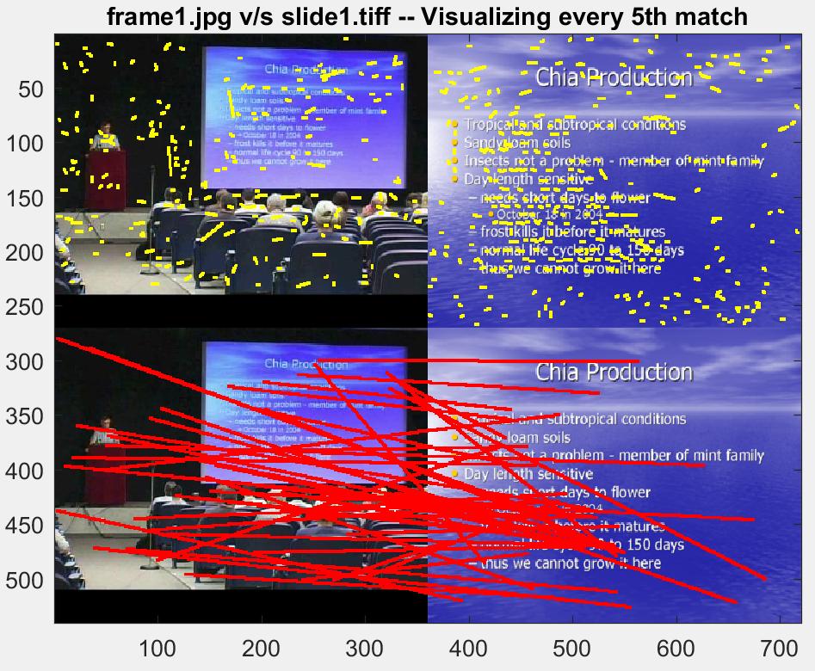

Figure 1. Frame1 v/s Slide 1 – Visualizing every 5th match found using nearest neighbor based on Euclidian distance. Yellow lines show the keypoints and red lines shows the matches.

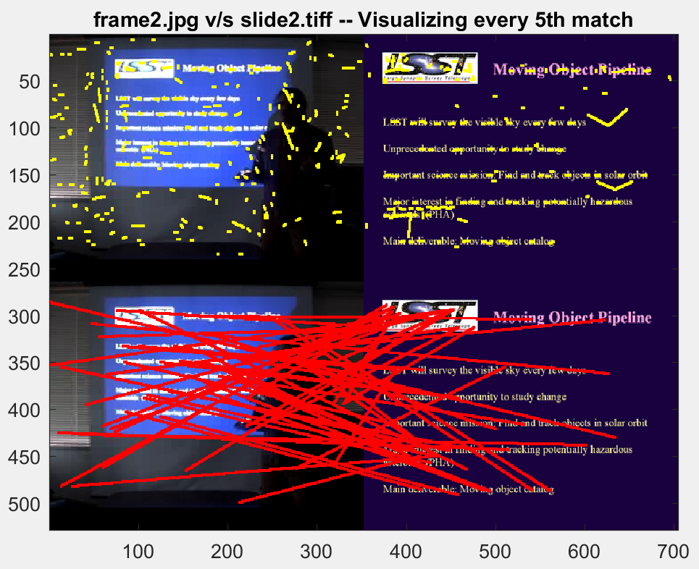

Figure 2. Frame2 v/s Slide 2– Visualizing every 5th match found using nearest neighbor based on Euclidian distance. Yellow lines show the keypoints and red lines shows the matches.

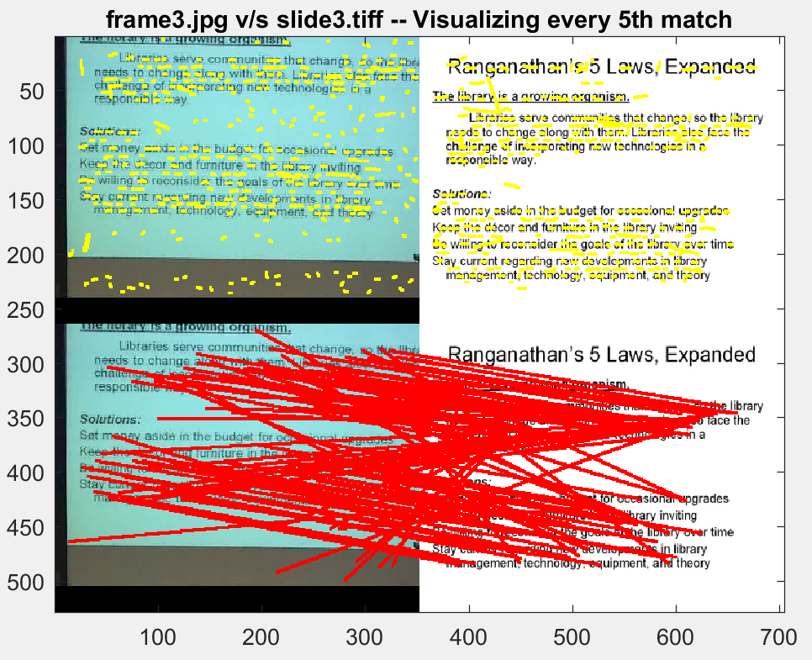

Figure 3. Frame3 v/s Slide 3 – Visualizing every 5th match found using nearest neighbor based on Euclidian distance. Yellow lines show the keypoints and red lines shows the matches.

Below is the code for detecting keypoints in the image using vl_sift.



Below is the code snippet for finding nearest neighbor using Euclidian distance.





To draw the lines on the images, I used the code from the link below as was indicated in the specification. <http://kobus.ca/teaching/cs477/code/draw_line.m>

1. Out of all the matches found with nearest neighbor algorithm using Euclidean distance, we now select best P% of the matches such that we roughly have 50% good matches and 50% bad matches. To find the best matches, we would sort the matches by Euclidean distance and pick top 40% with increasing Euclidean distance. I started with P=20% but found very few good matches. I found that **P=40%** is an optimal choice to find as many good matches as possible. Since the count of matches in the best 40% is high, we visualize every 3rd match.

Below images in Figure 4, 5 & 6 show this and it follows the same convention of yellow for keypoints and red for matches as before.

Below is the code snippet for drawing the matches

match = sortrows(match,3); %3rd column is the euclidean distance

for i=1:3:uint8(P*size(match,1))

y1=(ff(1,match(i,1)));

x1=(ff(2,match(i,1)));

y2=(size(if1_color,2) + fs(1,match(i,2)));

x2=(fs(2,match(i,2)));

p1=[x1 y1];

p2=[x2 y2];

Im2=draw_line(Im2, p1, p2, 1, 255, 0, 0);

end

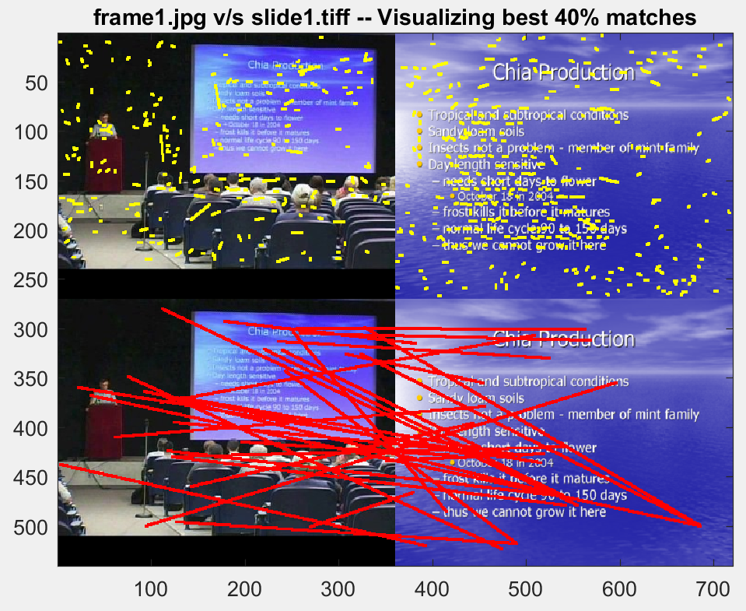

Figure 4. Frame1 v/s Slide 1 – Visualizing every 3th match of best 40% of matches.

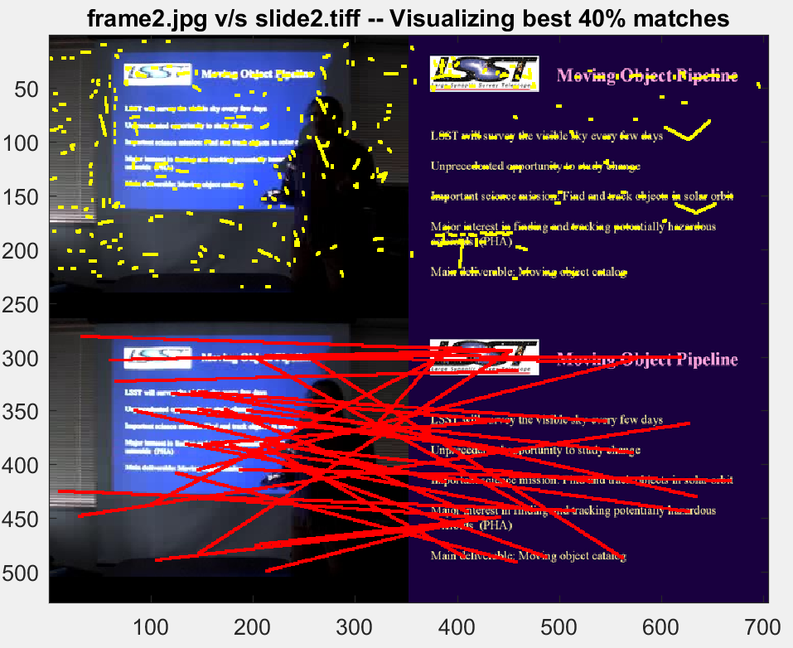

Figure 5. Frame2 v/s Slide 2 – Visualizing every 3th match of best 40% of matches.

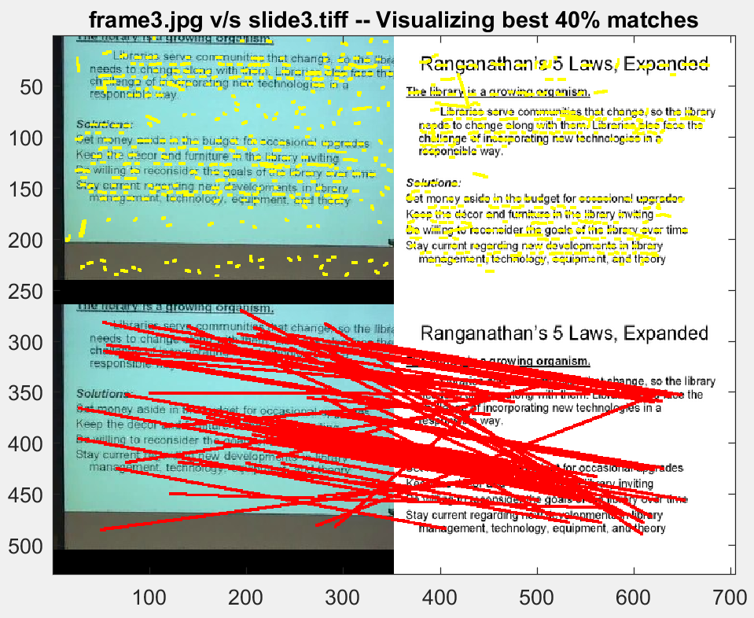

Figure 6. Frame3 v/s Slide 3 – Visualizing every 3th match of best 40% of matches.

1. We use the same P=40% but with angular distances for finding the nearest match as against the Euclidean distance as before. From the images below in Figure 7, 8 & 9, we can clearly see that we find better good matches and less bad matches with angular distances.

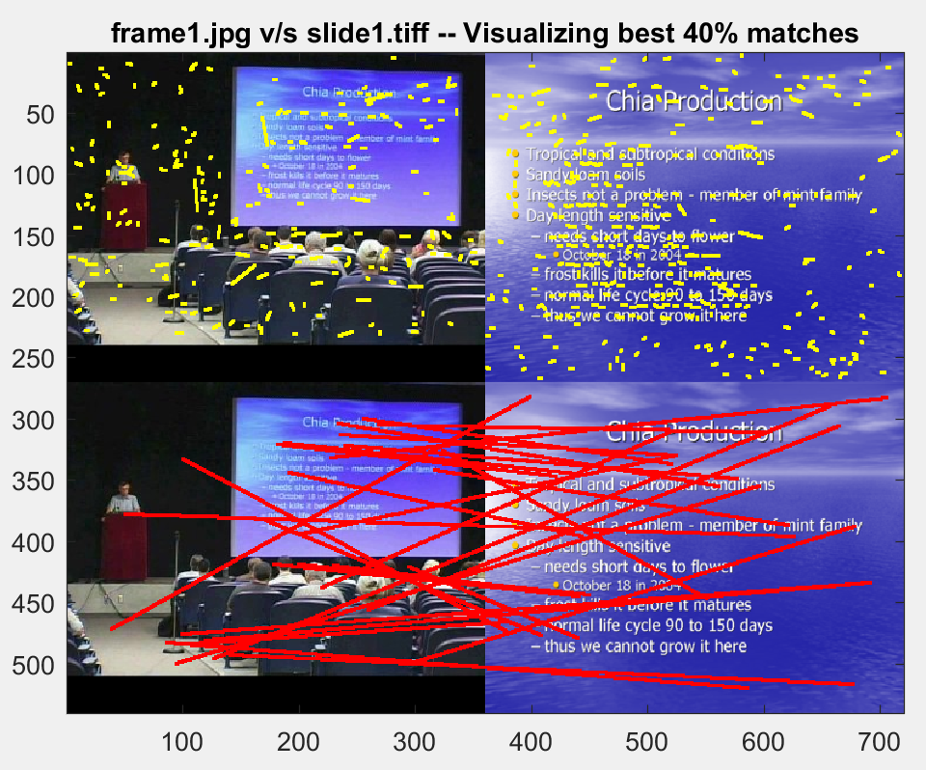

Figure 7. Frame1 v/s Slide 1 – Visualizing every 3th match of best 40% of matches. Found nearest match with angular distances.

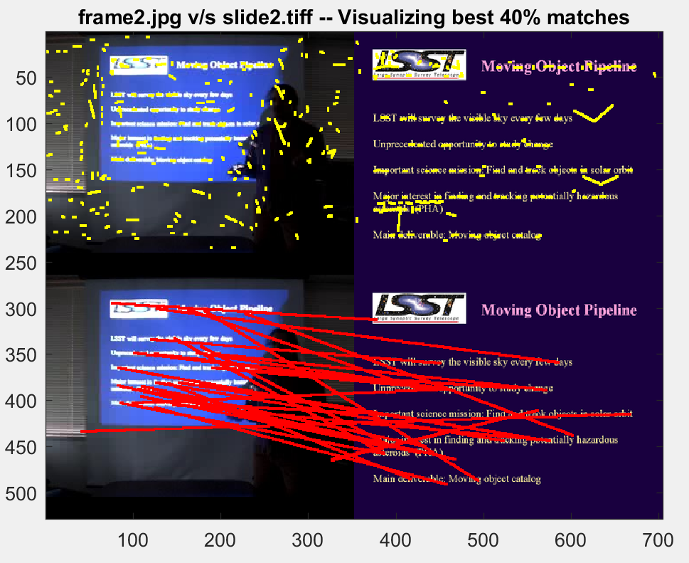

Figure 8. Frame 2 v/s Slide 2 – Visualizing every 3th match of best 40% of matches. Found nearest match with angular distances.

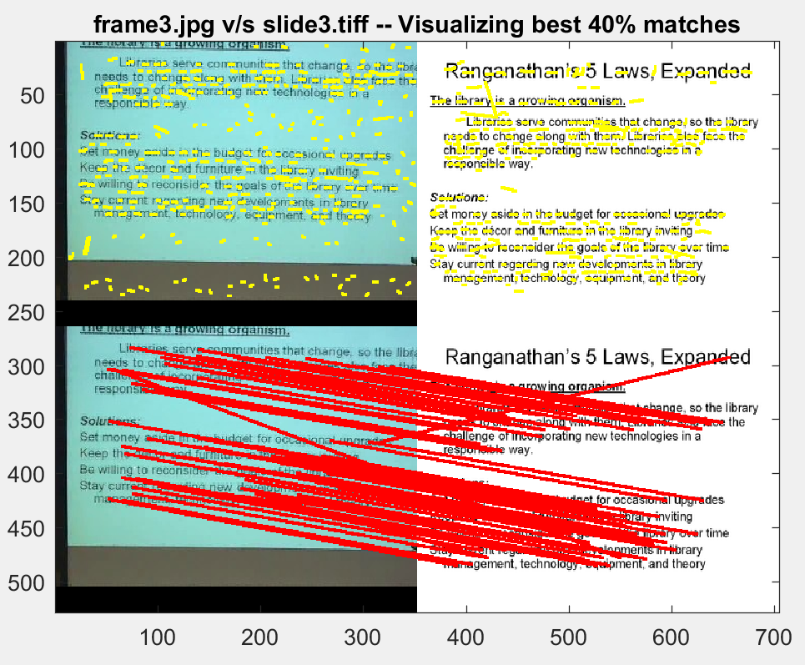

Figure 9. Frame 3 v/s Slide 3 – Visualizing every 3th match of best 40% of matches. Found nearest match with angular distances.

1. We use the Lowe’s suggestion regarding the ratio of the distance to the nearest neighbor and the second nearest neighbor make matching more robust. In particular, he rejected any match with ratio greater than 0.80. However, I found the **ratio set to 0.96** yields the best result.

|  |  |  |  |
| --- | --- | --- | --- |
|  | Frame 1 v/s Slide 1 | Frame 2 v/s Slide 2 | Frame 3 v/s Slide 3 |
| # of matches w/o Lowe’s optimization | 233 | 273 | 520 |
| # of matches w/ Lowe’s optimization | 123 | 163 | 374 |

Table 1. Number of matches with and without Lowe’s optimization.

Quantitatively, we can see that we have pruned the matches to keep only the best. However, when we visualize, we can observe that the result is roughly the same.

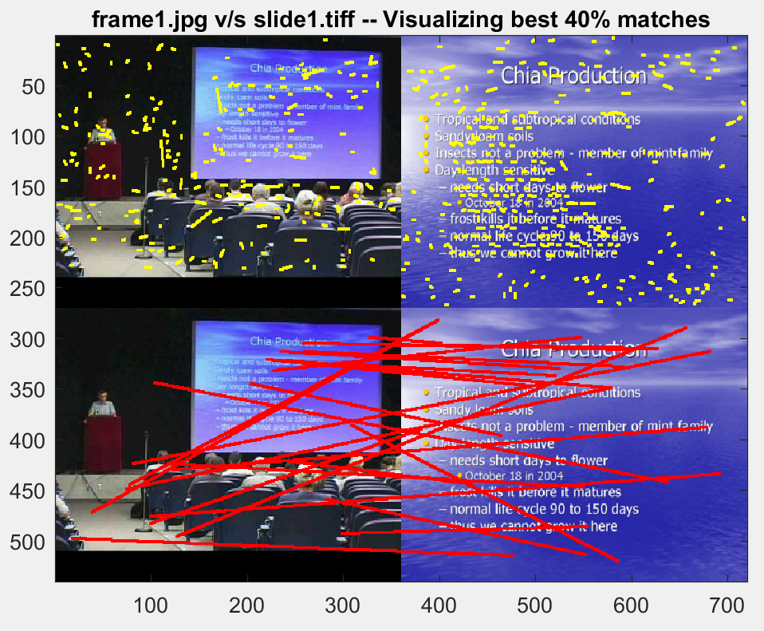

Figure 10. Frame 1 v/s Slide 1 – Visualizing every 2nd match of best 40% of matches. Found nearest match with angular distances and used Lowe’s optimization for pruning matches

Below is the code snippet for Lowe’s optimization.

match = zeros(size(df,2), 3);

for i=1:size(df,2)

d1 = df(:,i)';

[neighbor, n_dist, second_neighbor, second_n_dist] = find_nearest_neighbor(d1, ds, euclidean);

if(lowe_opt==1)

if((n_dist/second_n_dist) <= ratio)

match(i,1) = i;

match(i,2) = neighbor;

match(i,3) = n_dist;

end

else

match(i,1) = i;

match(i,2) = neighbor;

match(i,3) = n_dist;

end

end

match = match(any(match,2),:);

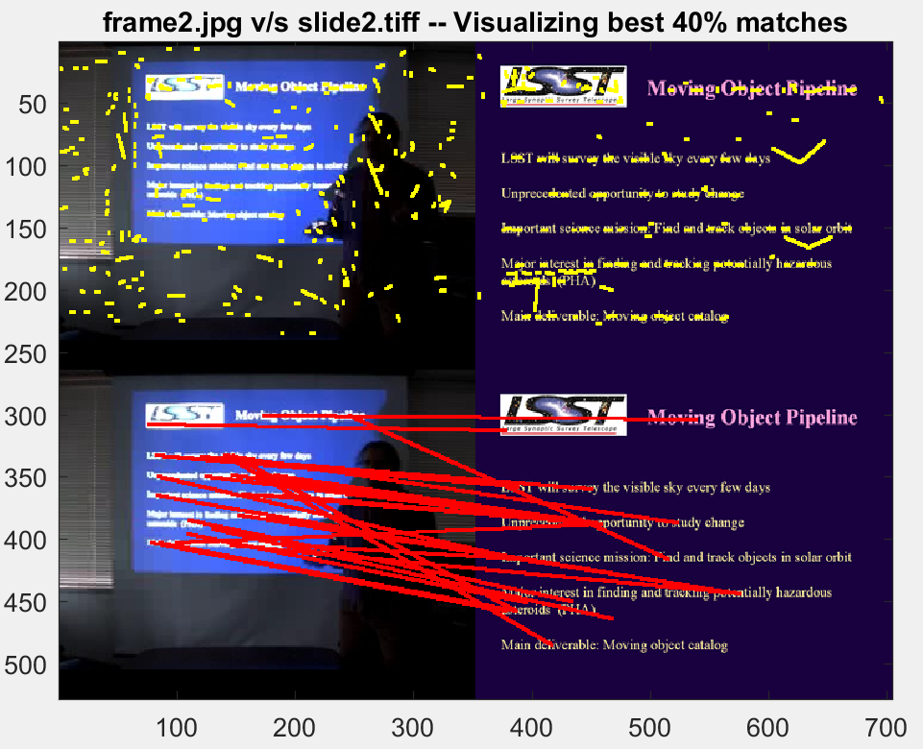

Figure 11. Frame 2 v/s Slide 2 – Visualizing every 2nd match of best 40% of matches. Found nearest match with angular distances and used Lowe’s optimization for pruning matches

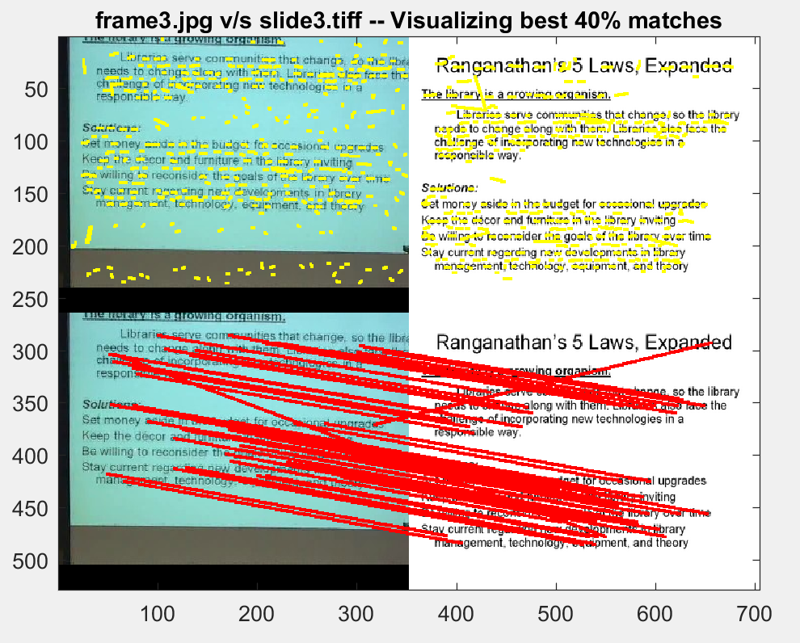

Figure 12. Frame 3 v/s Slide 3 – Visualizing every 2nd match of best 40% of matches. Found nearest match with angular distances and used Lowe’s optimization for pruning matches

1. Let us set the threshold T to the best of the parameters we have found so far. We will use Lowe’s optimization to prune matches with the ratio set to 0.96. We will only consider the best 40% of the matches. We will use angular distance for finding the nearest neighbor for the keypoint.

Below is the confusion matrix for the number of matches for all frame to slide pairs.

|  |  |  |  |
| --- | --- | --- | --- |
| # of matches | Slide 1 | Slide 2 | Slide 3 |
| Frame 1 | 123 | 107 | 67 |
| Frame 2 | 148 | 163 | 96 |
| Frame 3 | 259 | 251 | 374 |

Table 2. Confusion Matrix – showing number of matches for all frame to slide pairs

# PART B

We first find the first order Gaussian smoothened X and Y-order derivative.

$$I_{x}=G_{x}^{σ}*I \\ I_{y}=G_{y}^{σ}*I$$

We then compute the product of derivatives at every pixel.

$$I_{x2}=I_{x}.I_{x} \\ I_{y2}=I_{y}.I_{y} \\ I_{xy}=I_{x}.I_{y}$$

We then compute the sums of product of derivatives at each pixel in the given window.

$$S_{x2}=G_{σ^{'}}.I_{x2} \\ S_{y2}=G_{σ^{'}}.I_{y2} \\ S_{xy}=G_{σ^{'}}.I_{xy}$$

We calculate the symmetric matrix H at each pixel.

$$H\left(x,y\right)=\begin{matrix}{S(x,y)}_{x2} & {S(x,y)}_{xy} \\ {S(x,y)}_{xy} & {S(x,y)}_{y2}\end{matrix}$$

We then compute the response of the Harris corner detector at each pixel.

$$R\left(x,y\right)=Det\left(H\left(x,y\right)\right)-k*\left(Trace{\left(H\left(x,y\right)\right)}^{2}\right)$$

Below is the code snippet for the corner calculation,

function harris_corner_detector(image_path, threshold, window, k, sigma)

I=imread(image_path);

I=double(rgb2gray(I));

dx = [-1 0 1; -1 0 1; -1 0 1];

dy = dx';

h=2;

Ix = conv2(I, dx, 'same');

Iy = conv2(I, dy, 'same');

g = fspecial('gaussian',h, sigma);

Ix2 = conv2(Ix.^2, g, 'same');

Iy2 = conv2(Iy.^2, g, 'same');

Ixy = conv2(Ix.*Iy, g,'same');

R = zeros(size(I,1), size(I,2));

for i=1+window:size(I,1)-window

for j=1+window:size(I,2)-window

h11=mean(mean(Ix2(i-window:i+window,j-window:j+window)));

h12=mean(mean(Ixy(i-window:i+window,j-window:j+window)));

h21=mean(mean(Ixy(i-window:i+window,j-window:j+window)));

h22=mean(mean(Iy2(i-window:i+window,j-window:j+window)));

H=[h11 h12; h21 h22];

[V, D]=eig(H);

lam1=D(1,1);

lam2=D(2,2);

R(i,j)=lam1*lam2 - k*((lam1+lam2)/2)^2;

end

end

radius=6;

sze=2*radius+1;

mx = ordfilt2(R,sze^2,ones(sze));

R = (R==mx)&(R>threshold);

[r,c] = find(R);

figure, imagesc(I), axis image, colormap(gray), hold on;

plot(c,r,'ys'), title(image_path);

end

I experimented with different values for sigma for Gaussian smoothening, threshold, window size and the constant k. Below are the different values that I tried.

|  |  |  |
| --- | --- | --- |
|  | Alternative 1 (best) | Alternative 2 |
| Threshold | 500000 | 20 |
| Sigma (Gaussian smoothening) | 2 | 4 |
| Window size | 2 | 5 |
| k | 0.04 | 0.05 |

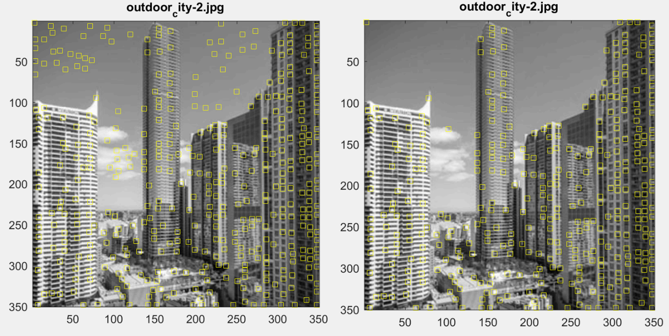

Figure 13. Left image w/ threshold 50. Right image w/ threshold 500000.

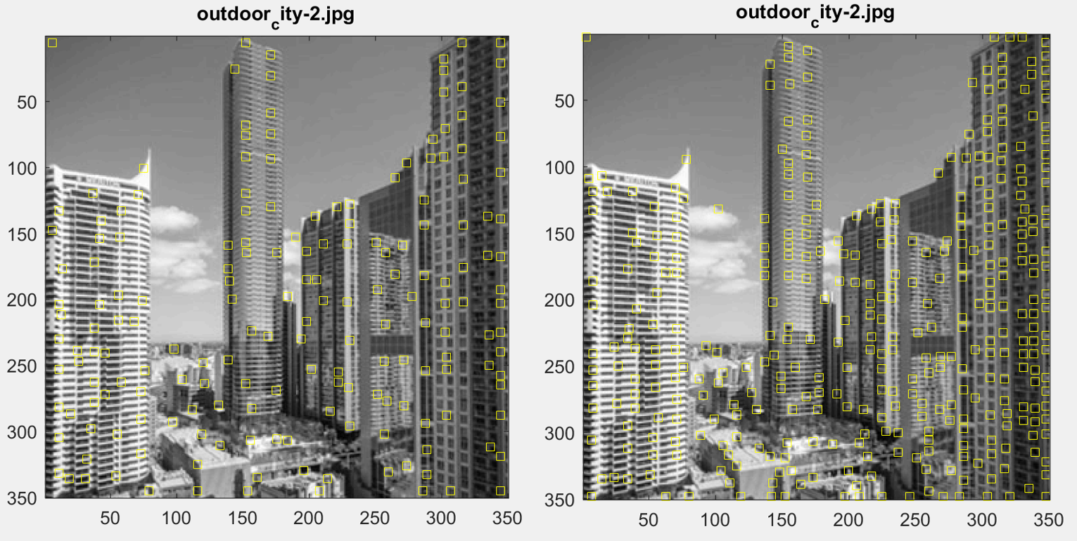

Figure 14. Left image w/ window size=5. Right image w/ window size=2.

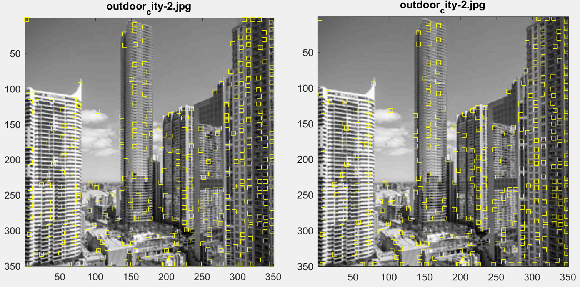

Figure 15. Left image w/ sigma=5. Right image w/ sigma=2.

Varying the threshold and window size made significant changes to corner detection. Whereas, varying sigma and constant k hardly resulted in any change.

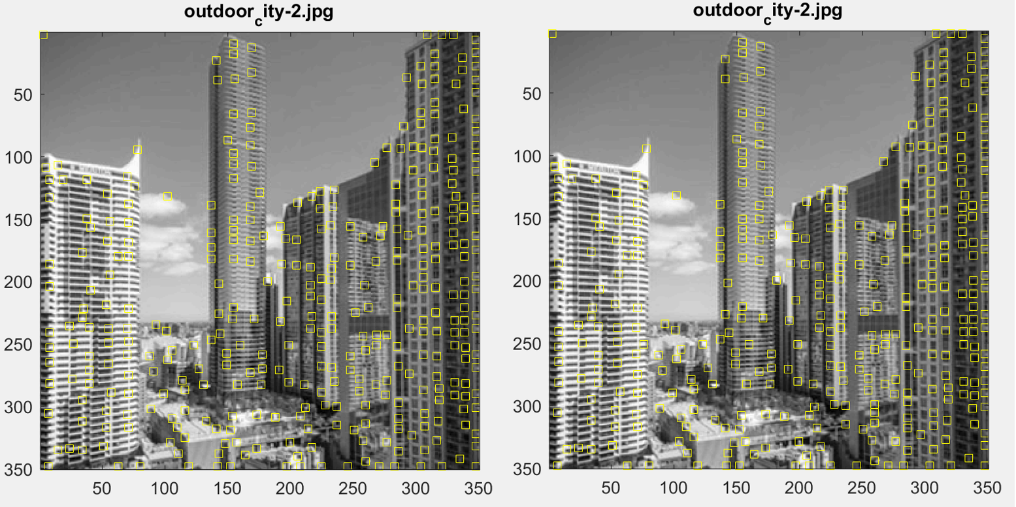

Figure 16. Left image w/ k=0.05. Right image w/ k=0.04

With the best configuration, i.e., (k=0.04, sigma=2, threshold=500000, window size=2), I tried the corner detection with different images. You can see the results below.

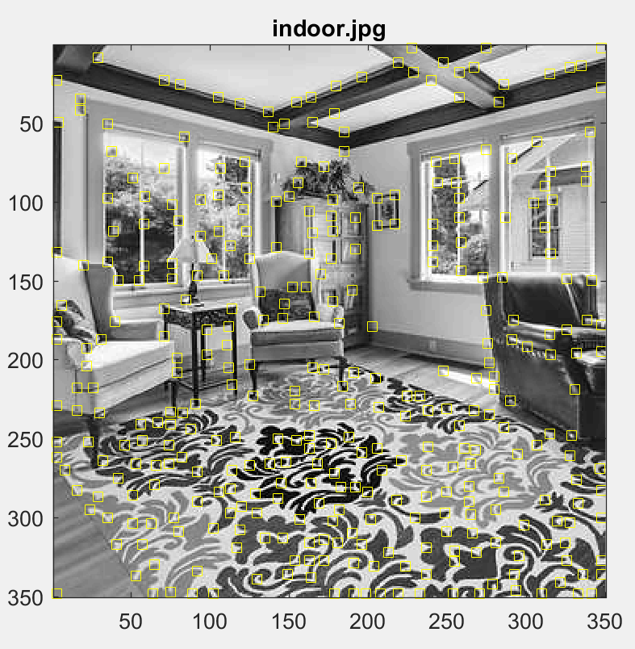

Figure 17. Indoor image w/ best configuration

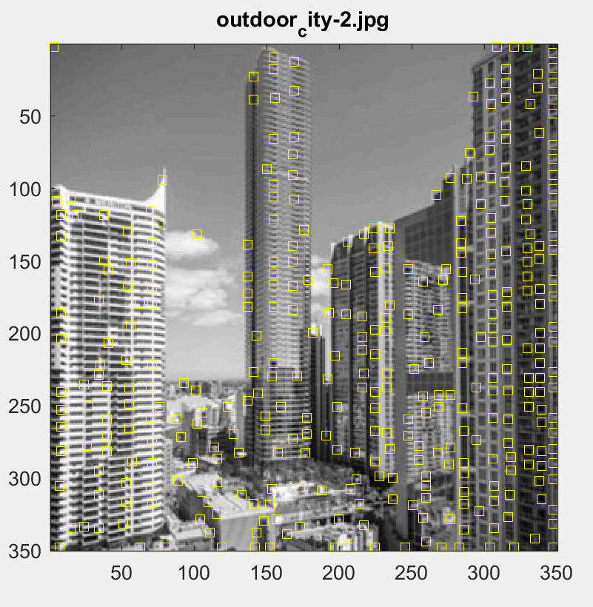

Figure 18. Outdoor city - 2 image w/ best configuration

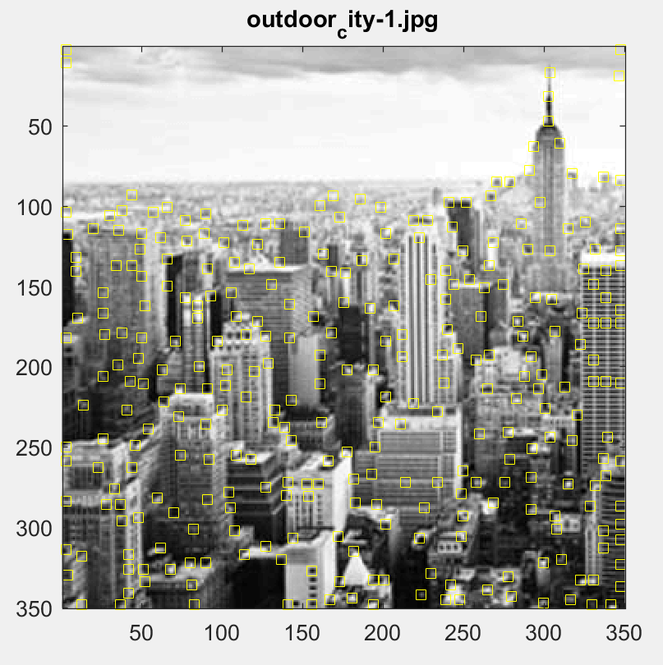

Figure 19. Outdoor city - 1 image w/ best configuration

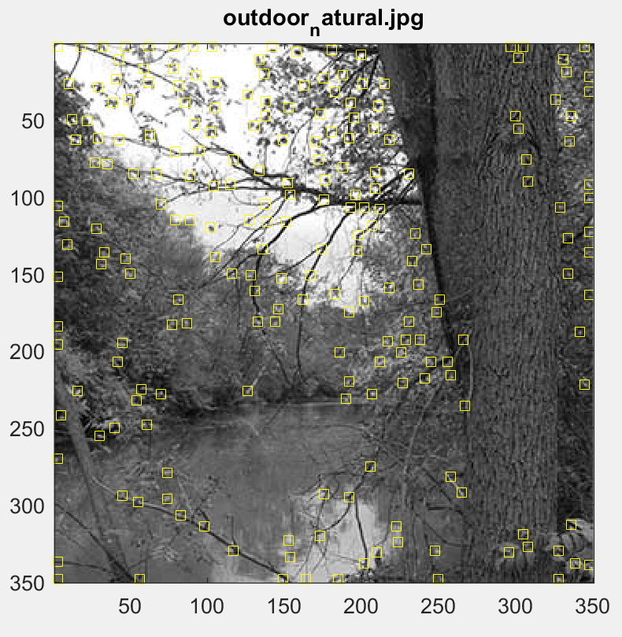

Figure 20. Outdoor natural w/ best configuration

This detector is rotationally invariant. I found it easier to confirm it in practice. I rotated one of the outdoor city images by an angle of 20 degrees to the left and ran the Harris corner detection algorithm. We could still find the right corners as before.

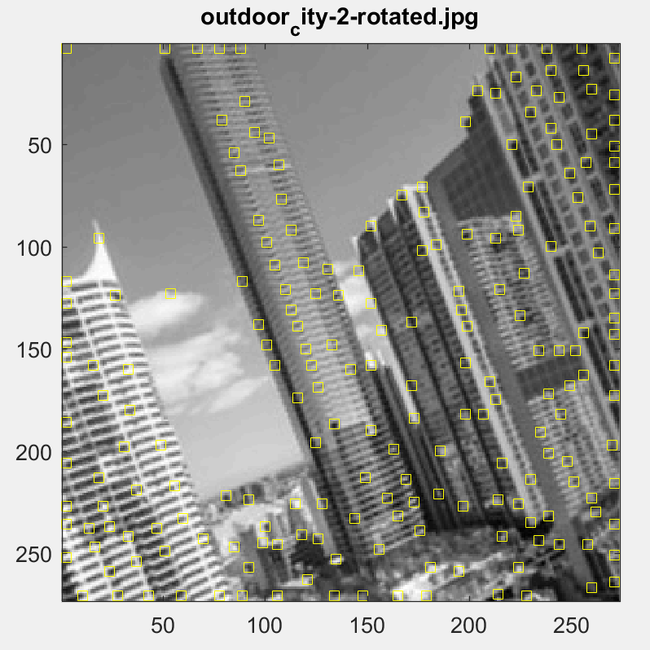

Figure 21. Outdoor natural w/ best configuration